**Scheme Module**

**Scheme List screen :**

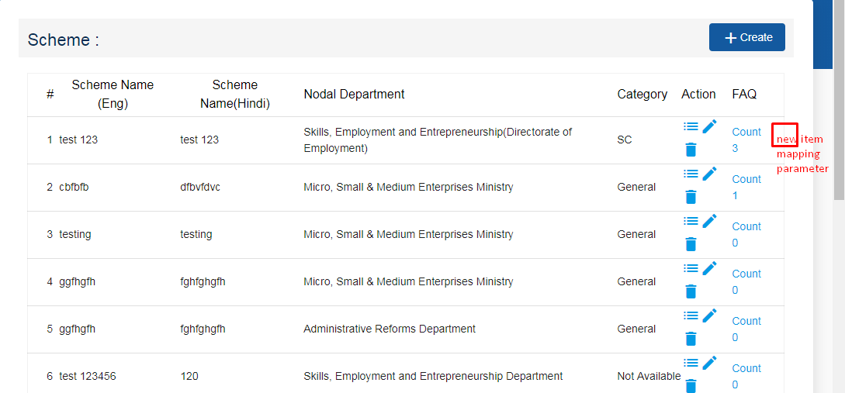

Add new action mapping parameter for scheme, on click of this we will redirect on “Add monitoring parameters screen”

**Scheme Add screen**

1. **Add new fields in scheme Add Screen**

1.1 Scheme short name in Hindi.

1.2 scheme short name in English.

1.3 Remove file upload for citizen character, act rule and scheme form and add new feature which upload multiple file with (subject, active/inactive, up-loader, category).Show in data in grid-form.

1.4 Scheme website URL.

2 **changes in fields**

2.1 Change multiple text-box to multiple select drop-down list for Required Document.

**New Monitoring screen**

* **Scheme Parameter Mapping** **(Screen 1)**
* **Scheme Data Entry Screen (Screen 2)**

1. Scheme parameters screen.

Mapping multiple parameter with particular scheme for rendering field for Scheme data entry screen.

Fields:

Scheme name

Remarks

Monitoring parameter(Mapping with Master Table )

Add more button (for adding multiple parameter)

|  |  |  |
| --- | --- | --- |
| **Field Name** | **Field Type** | **Description** |
| Scheme Name | DDL |  |
| Remarks | string |  |
| Monitoring parameter | DDL | Monitoring parameters master |

1. Scheme Data Entry Screen

Render all parameters and bind with their mapping table which will add from screen (Scheme parameters screen), and add Count field then add more button which repeat same flow then save this record

**Screen View(Grid) :**

|  |  |  |
| --- | --- | --- |
| **Field Name** | **Field Type** | **Description** |
| Scheme Name | Drop-down/Label | Scheme name |
| Count | string | Numeric form |
| All Monitoring parameter | DDL/Text/number | Monitoring parameter which mapping with particular Scheme |

All parameter data saved in separate row

**Master table for scheme**

* Scheme upload file category master.
* Scheme required document category master.
* Scheme category master.
* Scheme beneficial category master.
* Scheme output master .
* Scheme type master.

**Common for All above**

|  |  |  |
| --- | --- | --- |
| **Field Name** | **Field Type** | **Description** |
| Name | string |  |
| Name in Hindi | string |  |
| Active | True/false |  |

* Monitoring parameters master.

|  |  |  |
| --- | --- | --- |
| **Field Name** | **Field Type** | **Description** |
| Name | string |  |
| Name in Hindi | string |  |
| Mapping table name | String | Existing table name for mapping table. |
| Type | DDL | **Value:** Drop-down/string/number |

**Mapping table for scheme monitoring parameter**

1.Add monitoring parameters screen table (**Screen 1**).

|  |  |  |
| --- | --- | --- |
| **Field Name** | **Field Type** | **Description** |
| Scheme Id | number | Drop-down |
| Remark | string | Description |
| Monitoring Parameter | DDL | Monitoring parameters master. |

**Transaction table for scheme monitoring Data Entry**

Add data for monitoring parameters screen table(**Screen 2**).

Table 1

|  |  |  |
| --- | --- | --- |
| **Field Name** | **Field Type** | **Description** |
| Scheme Id | number |  |
| Count | number |  |

Table 2

|  |  |  |
| --- | --- | --- |
| **Field Name** | **Field Type** | **Description** |
| Scheme Id | number |  |
| Table 1 Id | number |  |
| Field ID | number | Master table PK which is added in screen 1 |
| Field Value | string | Field value selected by screen 2 |